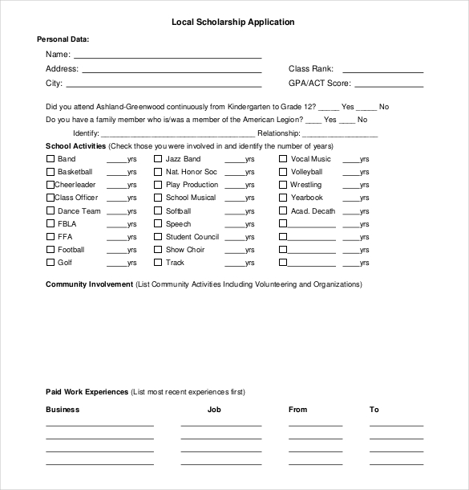

FiveCountyBoardofRealtors@gmail.com

By signing the application for this scholarship, I agree that I completed the 5 following items. 1. I met the requirements of outstanding performance in academic achievement with a GPA of 2.5 or greater and that I give my permission for the committee to request a copy of my high school grades. 2. I am a graduating senior enrolling as a full-time freshman at a certified 2 year college or 4 year university. 3. If granted the scholarship, I promise to use the funds for tuition, room & board or to purchase required text books. 4. I have also attached the required 2-5 page essay, entitled, “Why Homeownership is Important to Me?” 5. I have turned all documents in prior to 11:59 pm on April 15, 2018. E-mail: or Mail:   
   
  
____________________________________ _________________  
Signature of Applicant Date

Five County Board of Realtors   
Attn: Scholarship Committee  
PO Box 534, Nevada, MO 64772

**Deadline - April 15, 2018

Scholarship Application

School Activities (Check those you were involved in and identify the number of years)

|  |  |  |
| --- | --- | --- |
| Band _____yrs. | Golf _____yrs. | Track _____yrs. |
| Basketball _____yrs. | Nat. Honor Soc _____yrs. | Vocal Music _____yrs. |
| Cheerleader _____yrs. | School Musical _____yrs. | Volleyball _____yrs. |
| Class Officer _____yrs. | Softball _____yrs. | Wrestling _____yrs. |
| Dance Team _____yrs. | Speech _____yrs. | Yearbook _____yrs. |
| FBLA _____yrs. | Student Council _____yrs. | __________ _____yrs. |
| FFA _____yrs. | Show Choir _____yrs. | __________ _____yrs. |
| Football _____yrs. | Speech & Debate _____yrs. | __________ _____yrs. |

Paid Work Experiences (List most recent experiences first)  
 Business Job From To  
_______________________ _______________ _______________ _______________  
_______________________ _______________ _______________ _______________

Personal Data:  
 Name: _____________________________________________   
 Address: ____________________________________________ Class Rank: _______________  
 City: _______________________________________________ GPA/ACT Score: ___________

Do you have a family member who is/was a member of the 5 County Board or MLS? ___yes ___no  
 Identity: _______________________ Relationship: ______________________________



Community Involvement (List Community Activities Including Volunteering and Organizations)  
____________________________________________________________________________________________________________________________________________________________________________________________________________________________________________________________________________________________________________________________________________________________________________________________________________________________________________________________________________________________________________